Third Party Reporting Form  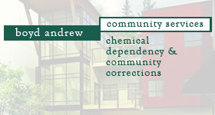  Sexual Abuse or Sexual Harassment on behalf of an Offender |  |  |  | Today’s Date:
Mail or email to: PREA Coordinator
Shawn Frederick
CM14@boydandrew.com
805 Colleen ST
Helena, MT 59601
Please complete this form to report sexual abuse or sexual harassment on behalf of an offender (resident).
Boyd Andrew Community Services will ensure that all staff, contractors, volunteers, and offenders/residents
are free from retaliation for reporting occurrences of sexual abuse or harassment.
CONTACT INFORMATION
Name (Last, First): |  |  | Phone (optional):
Best time to contact you: | ☐ Morning ☐ Afternoon ☐ Evening
DESCRIPTION OF INCIDENT
Date of incident (if known):
Offender(s) involved:
Staff member(s) involved:
Type of incident (if known): |  | ☐ Sexual Abuse ☐ Sexual Harassment ☐ Unknown
Facility of Offender: |  | ☐ Elk Horn Treatment Center ☐ Helena Pre-Release Center
Facility of Incident: |  | ☐ Elk Horn Treatment Center ☐ Helena Pre-Release Center
Description of the incident: (Please provide any information that may be useful in our investigation)
If you have additional questions or concerns please call PREA Coordinator at (406) 442-6572

